**Nov 2015 SL P1**

**Section A**

1. Human interaction with the computer system includes a range of usability problems.
2. Define the term usability. [1]

Usability means making the computer systems easy to use, matching them more closely to user needs and requirements;

1. Identify **two** methods that could be used to improve the accessibility of a computer

system. [2]

*Award up to* ***[2 max]***.

Voice recognition;

Text to speech;

Use of touch screen;

Braille keyboard; **[2]**

*Etc*.

1. By making direct reference to the technologies used, explain how a virtual private network  
    (VPN) allows a travelling salesperson to connect securely to their company’s network. [4]

*up to* ***[4 max]****.*

Tunnelling protocols;

Allows the data to be encapsulated/hidden whilst travelling across the internet;

Encryption protocols (IPSEC);

If hacked it will not be understandable;

The use of gateways;

Allows the salesperson to connect with the company’s server;

1. Construct a truth table for the following Boolean expression.  
     
    (A and B) nor C [3]

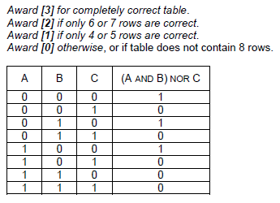

1. A small hotel buys a software package to manage their bookings.
2. Describe **two** types of documentation that should be provided with the software package. [4]

*Award* ***[1]*** *for each type and* ***[1]*** *for description, for two types, up to* ***[4 max]****.*

Technical documentation;

Describes how to install software;

Describes the hardware configuration needed;

User documentation;

Describes various functions of the software;

Helps users to learn how to use the software;

1. State **two** methods of delivering user training. [2]

*Award up to* ***[2 max]***.

Formal classes;

Self-instruction;

Online training;

1. A school uses a local area network (LAN) which connects several computers and a printer to

a server and allows access to the internet.

1. Define the term server. [1]

A computer system that serves as a central repository of data and programs and is shared by clients;

1. Identify the different clients in this network. [1]

Computer / Printer;

1. (i) Identify **one** external threat to the security of the school’s computer system. [1]  
     
     
     
     
     
     
     
   (ii) State one way to protect the computer system from the threat identified in

*Award* ***[1 max]***.

Viruses;

Spyware;

Hackers who attempt to crack the system;

***Note:*** *Do not accept theft/vandalism/natural disasters*

part (c)(i). [1]

*Award* ***[1 max]***.

Virus checker can be used to prevent viruses;

Spyware program run to check for spyware;

Firewall can be used to protect from hackers;

***Note:*** *Do not accept secure storage/guards/alarms to prevent theft in the building*

1. A sub-program all_even() accepts a positive integer N and outputs true if all digits of N

are even, otherwise it outputs false. For example, all_even(246) outputs true and

all_even(256) outputs false.

The following algorithm is constructed for the sub-program all_even(N).

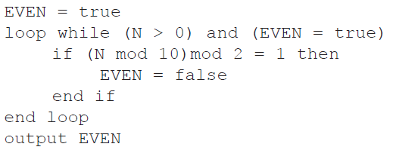

1. Explain why this algorithm does not obtain the correct result. [2]

*Award up to* ***[2 max]***.

The value of N is never changed;

So the logical expression in the while loop always evaluates to true;

And loop repeats an infinite number of times;

1. Outline what should be changed in the algorithm to obtain the correct result. [3]

Statement N = N div 10;

Should be written within the while loop;

After the if statement;

**Section B**

1. A hardware shop supplies a wide variety of bathroom equipment. There are 15 shop

assistants who serve customers, 3 office staff who handle the administration, and a manager.

A specialized company is asked to design and implement a new computer system for

the shop..

1. (i) Identify two different types of users of the system. [2]

*Award up to* ***[2 max]***.

Customers;

Employees – shop assistants;

Employees – office staff;

Manager / Owner; **[2]**

*Award* ***[1]*** *for “Employees”, if type of employee is not specified.*

(ii) Explain the role of users in the process of developing the new computer system. [3]

*Award up to* ***[3 max]***.

Role of users is important because inadequate user involvement leads to project failure;

All users must participate and explain how they use the system;

All users must participate and explain what they think is wrong with the system;

Users (managers, owners) are involved in approval of projects and budgets;

All users are involved in testing of the system;

All users are involved in training;

*Etc*.

1. Describe why it is useful to produce more than one prototype of the new system. [2]

More than one prototype allows the manager to choose the one that is the most suitable;

Which gives more flexibility and improves final system;

1. Outline **two** problems that may occur when transferring data from the old system to the

new system. [4]

*Award* ***[2]*** *for a correct answer,* ***[1]*** *for an answer with some credit, for two problems.*

*Example answers:*

The data records in databases could have different structures (fields);

The data files could be incompatible, from different hardware systems;

The key fields of different data types can exist;

The customer records could have same keys (IDS) so they cannot be uniquely identified;

The new system is implemented using parallel running.

1. (i) Outline what is meant by parallel running. [2]

Simultaneous operation;

Of the new and old system;

(ii) Outline one reason for choosing parallel running as opposed to a direct changeover. [2]

*Award up to* ***[2 max]***.

As the old system is still running;

The new system could be evaluated/used;

Without any consequences if the new system fails;

1. 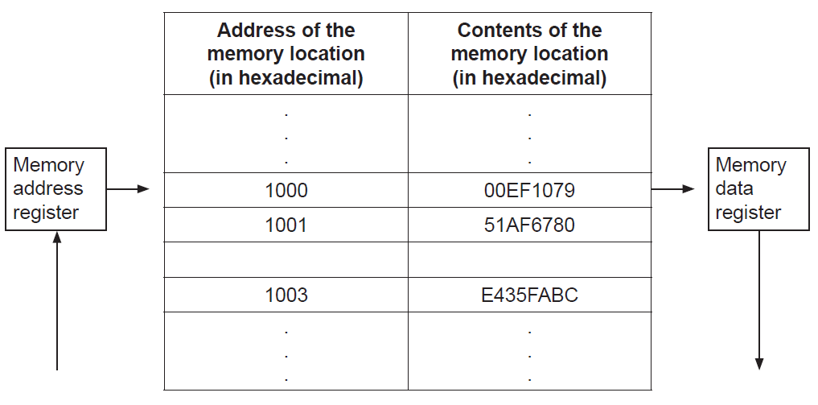The following diagram shows the structure of the random access memory (RAM).
2. Calculate the number of bits in each memory location. [1]

32

1. Calculate the number of bytes in each address. [1]

2

1. Outline the function of the:
2. memory address register [2]

*Award up to* ***[2 max]***.

MAR is a register in the CPU;

Loaded with the address of the next instruction/data;

To be taken from the RAM;

1. memory data register. [2]

*Award up to* ***[2 max]***.

MDR is a register in the CPU;

Holding the data which is most recently;

Taken from RAM

1. (i) Identify two functions of the operating system. [2]  
     
     
     
     
     
     
   (ii) State where the operating system is held when the computer is turned off. [1]

*Award up to* ***[2 max]***.

Resource allocation;

Memory management;

Interrupt handling; **[2]**

*Etc*.

*Award up to* ***[1 max]***.

Hard disk;

ROM;

Solid state disk (SSD)

The machine instruction cycle refers to the retrieval of an instruction from the RAM, and  
 subsequently decoding, executing and storing the result.

1. (i) Construct a diagram to illustrate the structure of a central processing unit (CPU),

clearly showing the flow of data within the CPU. [4]

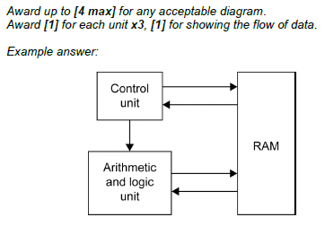

(ii) Identify the part of the CPU which performs decoding. [1]

Control Unit

(iii) Identify the part of the CPU which executes the instruction. [1]

Arithmetic and Logic Unit (ALU)

1. A candy company manufactures 20 different kinds of candy, each identified by a product ID.

An array, Product_ID, is used to store the product IDs, and another array, Unit_Price, is

used to store the price per unit of each type of candy. The unit price of the product identified

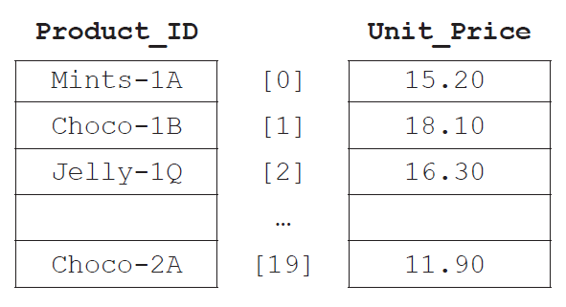by Product_ID[N] is equal to Unit_Price[N] for any index N.

1. State the price of the candy identified by Product_ID[2]. [1]

16.30;

1. Explain the steps that would be needed in an algorithm to calculate the average unit

price. [3]

Set a variable (sum) to zero;

Loop through the array Unit_Price;

Add each array element to variable sum;

Divide sum by 20;

1. Construct the algorithm that will output the price of a candy after its product ID is

entered by the user. The algorithm should output an appropriate message if the

product ID entered does not appear in the array Product_ID. [6]

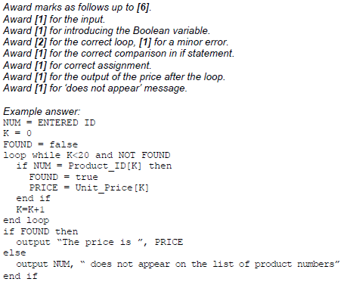

The company maintains two warehouses each of which stocks a selection of the 20 types of  
candy indicated above.  
  
The first warehouse stocks 15 items and their IDs are stored in an array, One. The second  
warehouse stocks 10 items and their IDs are stored in an array, Two.

All product IDs common to both warehouses will be placed in an array, Three.

1. (i) State the maximum number of common product IDs which can be placed   
    in Three. [1]

10

(ii) Construct the algorithm that will place all product IDs common to both  
 warehouses in Three. [4]

